*Submitted to:*

**Mr. Qasim Malik**

*Submitted by:*

**Khadija Tuz Zehra**

**(FA19-BCS-033)**

Topics in computer science-ii (DevOps)

Assignment # 02

January 3, 2023

Contents

PART (1) Containerized deployment of a web application. 1

Create a directory and clone your github project: 1

Inside the directory create a dockerfile and add the following commands in the Dockerfile: 1

Login to Docker: 1

Build the docker image: 2

Push the image to dockerhub: 2

Create a test directory in the root and add docker-composer.yml file: 3

Initialize an empty mysql directory in the test folder and run the mysql container: 3

Start the app container: 3

Output 4

Link 4

PART (2) Creation of an automation pipeline 5

Pipeline Scipt 5

Build Output 5

# PART (1) Containerized deployment of a web application.

## Create a directory and clone your github project:

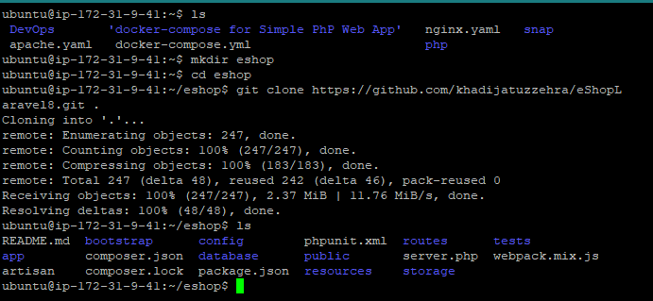

## Inside the directory create a dockerfile and add the following commands in the Dockerfile:

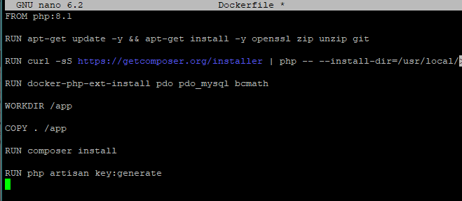

## Login to Docker:

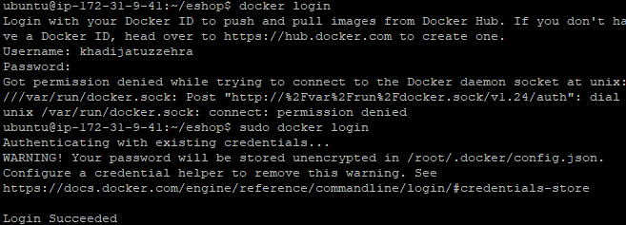

## Build the docker image:



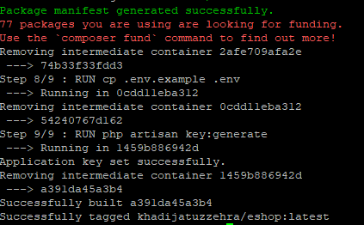

## Push the image to dockerhub:

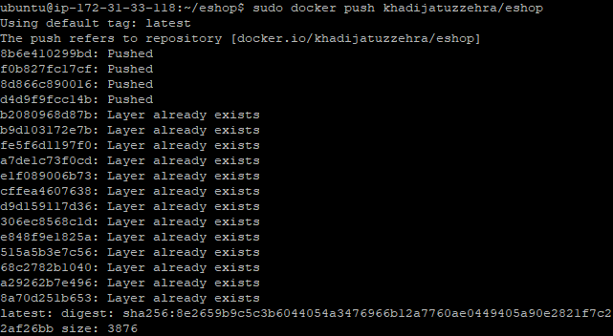

## Create a test directory in the root and add docker-composer.yml file:

## Initialize an empty mysql directory in the test folder and run the mysql container:

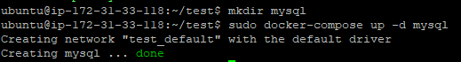

## Start the app container:

## Output



## Link

<http://ec2-13-230-127-101.ap-northeast-1.compute.amazonaws.com:8181/>

# PART (2) Creation of an automation pipeline

## Pipeline Scipt

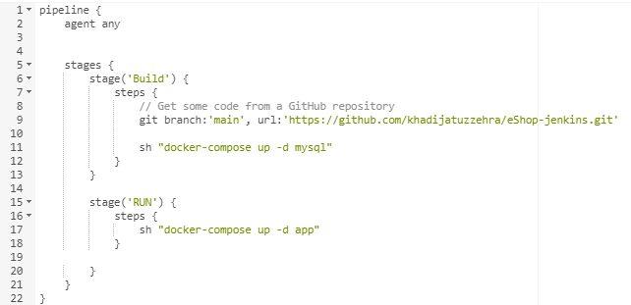

## Build Output

